Отчёт по лабораторной работе №5
  - Computer Skills for Scientific Writing
Кодже Лемонго Арман
Содержание
Цель работы 1
Exercises 1
Выполнение работы 2
Exercises 2
Use the simple table example to start experimenting with tables. 2
Try out different alignments using the l, c and r column types. 3
What happens if you have too few items in a table row? 5
How about too many? 6
Experiment with the command to span across columns 6
Выводы 7
Список литературы 7

Список иллюстраций
No table of figures entries found.

Цель работы
We will assume you load the array package, which adds more functionality to LaTeX tables, and which is not built into the LaTeX kernel only for historic reasons. So put the following in your preamble and we’re good to go.

Exercises
- Use the simple table example to start experimenting with tables.
- Try out different alignments using the l, c and r column types.
- What happens if you have too few items in a table row?
- How about too many?
- Experiment with the command to span across columns

Выполнение работы

Exercises

Use the simple table example to start experimenting with tables.
\documentclass{article}
\usepackage[T1]{fontenc}
\usepackage{array}
\begin{document}
\begin{tabular}{lll}
Animal & Food & Size \\
dog & meat & medium \\
horse & hay & large \\
frog & flies & small \\
\end{tabular}
\end{document}
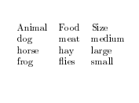
\documentclass{article}
\usepackage[T1]{fontenc}
\usepackage{array}
\begin{document}
\begin{tabular}{cp{9cm}}
Animal & Description \\
dog & The dog is a member of the genus Canis, which forms
↪ part of the
wolf-like canids, and is the most widely abundant
↪ terrestrial
carnivore. \\
cat & The cat is a domestic species of small carnivorous
↪ mammal. It is the
only domesticated species in the family Felidae and
↪ is often referred
to as the domestic cat to distinguish it from the
↪ wild members of the
family. \\
\end{tabular}
\end{document}
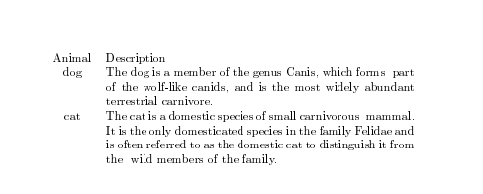

Try out different alignments using the l, c and r column types.
\documentclass{article}
\usepackage[T1]{fontenc}
\usepackage{array}
\usepackage{booktabs}
\begin{document}
\begin{tabular}{lll}
\toprule
Animal & Food & Size \\
\midrule
dog & meat & medium \\
\cmidrule{1-2}
horse & hay & large \\
\cmidrule{1-1}
\cmidrule{3-3}
frog & flies & small \\
\bottomrule
\end{tabular}
\end{document}
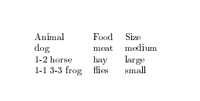
\documentclass{article}
\usepackage[paperheight=8cm,paperwidth=8cm]{geometry}
\usepackage{array}
\usepackage{longtable}
\begin{document}
\begin{longtable*}{cc}
\multicolumn{2}{c}{A Long Table}\\
Left Side & Right Side\\
\hline
\endhead
\hline
\endfoot
aa & bb\\
Entry & b\\
a & b\\
a & b\\
a & b\\
a & b\\
a & bbb\\
a & b\\
a & b\\
a & b\\
a & b\\
a & b\\
a & b\\
a & b b b b b b\\
a & b b b b b\\
a & b b\\
A Wider Entry & b\\
\end{longtable*}
\end{document}
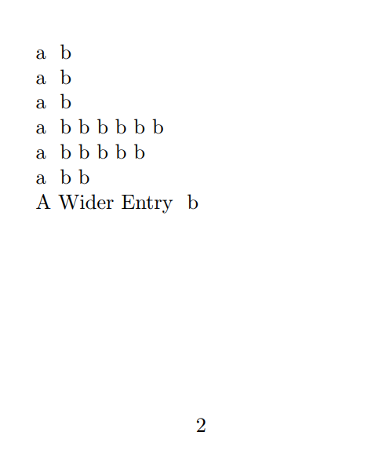

What happens if you have too few items in a table row?
If a row in a LaTeX table contains fewer elements than the declared columns, a warning or error occurs during compilation. This is because LaTeX expects exactly the specified number of cells separated by characters.
This problem is solved either by adding missing empty cells (for example, leaving empty spaces between &), or by adjusting the number of columns in the table declaration.
\begin{tabular}{l c r}
Значение 1 & Значение 2 \\ % Ошибка, ожидается 3 элемента
\end{tabular}
The problem is there are fewer elements than columns
solution: added an empty cell for the third column
\begin{tabular}{l c r}
Значение 1 & Значение 2 & \\
\end{tabular}

How about too many?
If a row in a LaTeX table contains more elements than the declared columns, a compilation error occurs with a message along the following lines: “Extra alignment tab has been changed to ” or “You have written too many alignment tabs in a table”. This is because LaTeX expects exactly the number of cells in a row that is specified in the table definition (the number of columns), and accordingly exactly the number of & separators (one less than the number of columns).
\begin{tabular}{c c c}
1 & 2 & 3 & 4 \\
\end{tabular}
Error: 3 columns are declared, but 4 elements in a row
solution 1: Remove the extra element
```latex
\begin{tabular}{c c c}
1 & 2 & 3 \\
\end{tabular}
solution 2: add a column in the add
\begin{tabular}{c c c c}
1 & 2 & 3 & 4 \\
\end{tabular}

Experiment with the command to span across columns
\documentclass[a4paper]{article}
\usepackage[T1]{fontenc}
\usepackage{array}
\usepackage{ragged2e}
\begin{document}
\begin{table}
\begin{tabular}[t]{lp{3cm}}
One & A long text set in a narrow paragraph, with some more
↪ example text.\\
Two & A different long text set in a narrow paragraph, with
↪ some more hard to hyphenate words.
\end{tabular}%
\begin{tabular}[t]{l>{\raggedright\arraybackslash}p{3cm}}
One & A long text set in a narrow paragraph, with some more
↪ example text.\\
Two & A different long text set in a narrow paragraph, with
↪ some more hard to hyphenate words.
\end{tabular}%
\begin{tabular}[t]{l>{\RaggedRight}p{3cm}}
One & A long text set in a narrow paragraph, with some more
↪ example text.\\
Two & A different long text set in a narrow paragraph, with
↪ some more hard to hyphenate words.
\end{tabular}
\footnotesize
\begin{tabular}[t]{lp{3cm}}
One & A long text set in a narrow paragraph, with some more
↪ example text.\\
Two & A different long text set in a narrow paragraph, with
↪ some more hard to hyphenate words.
\end{tabular}
\end{table}
\end{document}
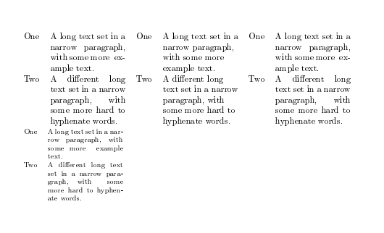

Выводы
в конце нашего лабораторная работа, я освоил основы включения и управления Tables в документах LaTeX.

Список литературы
- latex

